What is NIEM?
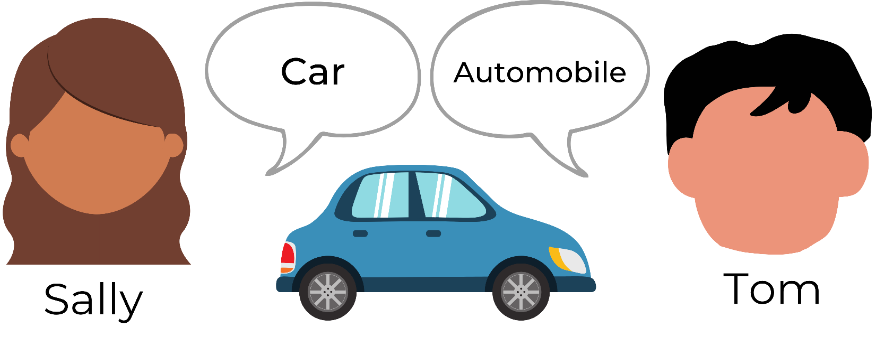
The National Information Exchange Model (NIEM) helps different organizations share information smoothly and consistently by providing a common vocabulary.
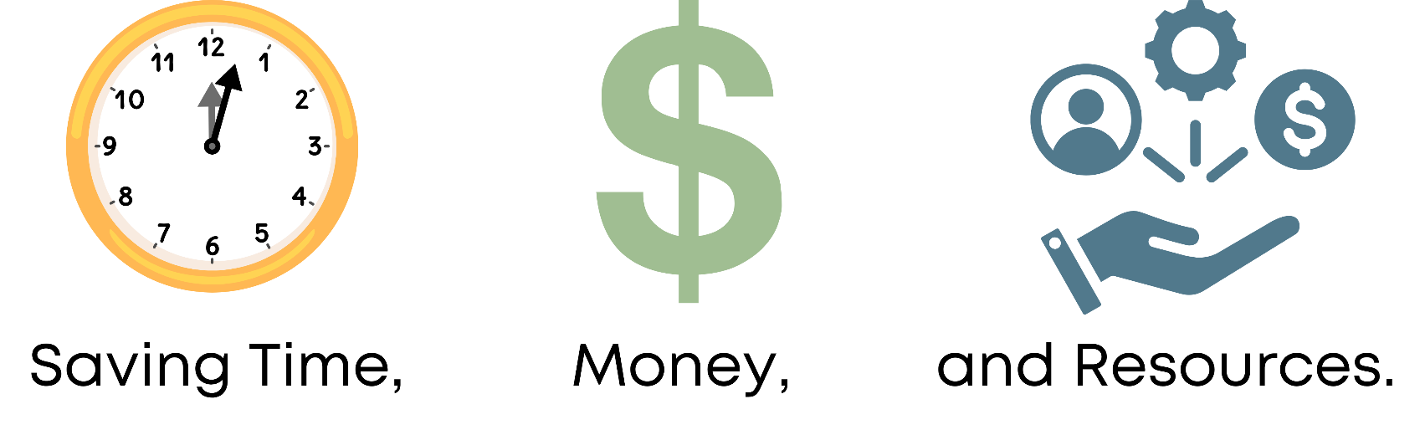
So, when Sally and Tom exchange information, NIEM lets their systems understand each other, even if one says 'car' and the other says 'automobile.'

Contact today to get started with NIEM!

