Understanding Ribbon Charts
A ribbon chart (also called an alluvial diagram or Sankey diagram) visualizes how the rank of categories changes over time. The width of each "ribbon" or flow represents the quantity or proportion of data moving between categories. They are particularly useful for visualizing trends and shifts in ranking for various data points.

Key Elements of a Ribbon Chart
- Ribbons: Each "ribbon" represents a category (e.g., a specific drug subcategory, a locality). The width of the ribbon indicates its value or quantity at a given point in time.
- X-axis (Time Axis): This axis typically represents time, such as months or years.
- Y-axis (Value Axis): This axis represents the quantity or value of the categories.
- Rank: The vertical position of the ribbons on the Y-axis indicates their rank. Categories with higher values will appear higher on the chart.
- Color: Different colors are used to distinguish between categories.

How to Read and Interpret Ribbon Charts
- Identify the categories by looking at the different colored ribbons being tracked (e.g., "Cannabis - Marijuana," "Illicit Synth - Fentanyl," "Cocaine" in the "Quantity of Seized Substances" chart).
- Follow a single ribbon across the X-axis to see how its quantity or value changes over time.
  - Increasing/Decreasing Quantity: If a ribbon widens, the quantity has increased. If it narrows, the quantity has decreased.
  - Changing Rank: Observe if a ribbon moves up or down relative to other ribbons. This indicates a change in its ranking. For example, if a ribbon moves from a lower position to a higher position, its rank has improved.
- Compare Categories by reviewing the dominant categories and any shifts in the dominance.
  - Dominant Categories: Look for the widest ribbons, as these represent the categories with the highest quantities or values at that specific time.
  - Shifting Dominance: Notice if different ribbons become dominant or wider at different times. Changes in the width shows shifts in the most prevalent categories.
- Sharp changes in a ribbon's width or position might indicate specific events or trends that warrant further investigation.

Substance Use Disorder Abatement (SUDA) Example
Let's look at the "Quantity of Seized Substances by Year, Month, and Top 10 Drug Subcategories" chart.
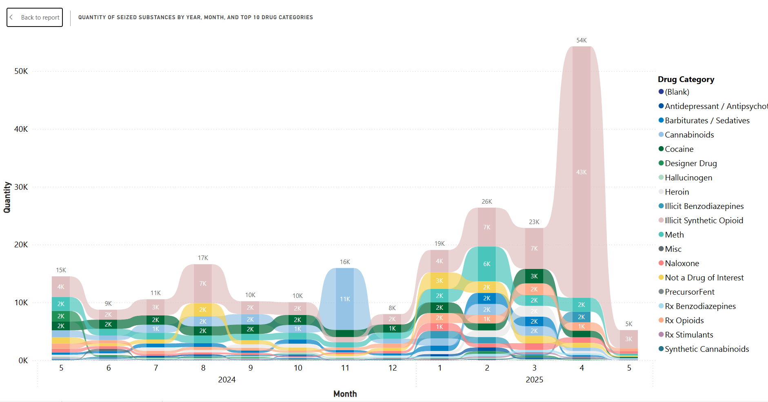
- Ribbons: Each colored ribbon represents a specific drug subcategory (e.g., "Illicit SynthOpioid," "Cocaine," "Heroin").
- X-axis: This shows months across 2024 and 2025.
- Y-axis: This represents the Quantity of seized substances.
By observing this chart, you can:
- See how the quantity of "Illicit SynthOpioid" (top drug category by quantity) has changed month-to-month.
- Compare the quantities of different drug subcategories at any given month.
- Identify which drug subcategories were more prevalent in certain months compared to others.
Similarly, the "Weight of Seized Substances by Year, Month, and Top 10 Drug Subcategories" chart uses ribbons to show trends in weight for different drug subcategories. The "Quantity of Seized Substances by Year, Month, and Locality" chart also uses this format to display quantity trends across different localities.
By following these steps, you can effectively interpret the information presented in ribbon charts within the SUDA Analytics Platform.

